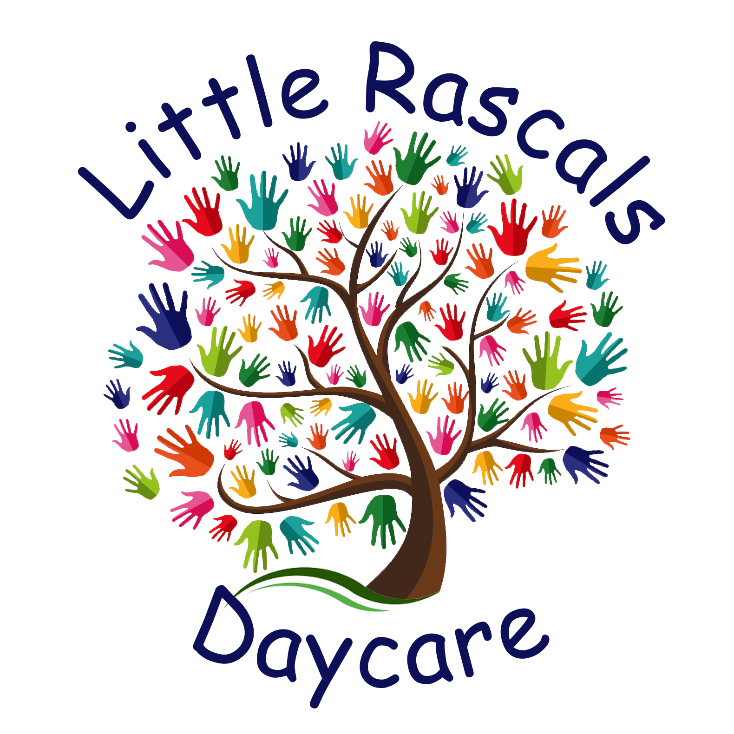

Little Rascals
Policy book

Contact Information

Provider Name: Jenee Babic
Phone Number: 218-731-6690
Provider# 1102229

Email: Jenee11@outlook.com

Welcome to My child care! I’m so excited to experience life with your child!! . My daycare is designed to be a loving, relaxed, trusting and safe home-like environment where children are encouraged to pursue their own interests, develop friendships, and grow in confidence; independence and respect for themselves and others.
My goal is to create a fun environment in which learning is experienced through choices and play , friendships . Here at Little Rascals I offer a variety of indoor and outdoor activities. Your child may also participate in activities such as learning time, arts and crafts, toys and games, reading, music ,free play, sensory projects as well as relaxing quiet time. I offer a semi-structured day and believe that following a structured routine most days leads to more confidence in the children I care for. I’m so excited to get to know your children and watch them blossom into fine young caring individuals!

Discipline: ​
Discipline is a learning process and not a punishment. All Misbehavior will be handled in a firm, consistent, and positive manner. Discipline will be appropriate for the age of the child and the severity of the behavior. Behavior management methods will focus on making the children accountable for their behaviors and teaching respect for self, others and their surroundings.
1. Communicate- ask questions and involve the child in behavior decisions
2. Redirection/distraction
3. Sit and watch (quiet time)
4. Corrective teaching
5. Loss of privilege or toy
6. Natural consequences
7. Positive reinforcement
8. Proactive planning with parents and provider.

Emergency Procedures: ​In the case of emergency, all my safety procedure protocols will be followed. If a child is injured and medical assistance is needed, 911 would be called followed by parent notification. If a child is injured and no medical assistance is needed, the parent would be notified as soon as possible of the injury. I will also send home an accident report in the event of any accidents in my care! There are fire and safety procedures that are posted in the residence and practiced and logged monthly with the children you will find these posted on the parent bulletin board.

Immunization Records:
​I am required to have immunization records on file for each child enrolled in childcare. These records need to be updated regularly according to the age of the child. I will send a note that an updated record is needed, please return it promptly! If a child has an immunization that falls on a daycare day that child must stay home to be monitored incase of any reactions.

Discrimination: ​I believe all children are created equally and therefore I will not discriminate in relation to admissions on the basis of race, color, national origin, religion, or sex. I am also required to follow the practices outlined in the Americans with Disabilities Act.

My Hours & Rates

My Weekly Schedule:
I am open Monday -Thursday 7- 445 pm all the kids must be picked up by 4:45pm as my kiddos have activities, I need to be at by 5!
Saturday and Sunday: Closed
**Please respect opening times by bringing your kiddos at our contracted times only and please pick up by 445 pm as my doors lock at 445 pm! A $5 fee will be charge for every 5 minutes or more lately to pickup child, unless approved by me beforehand! Communication is key!

MY Paid Holidays & Paid Vacation Time
My Home Daycare recognizes Federal Holidays and will be closed and paid for the following holidays: All enrolled are required to pay these holiday as long as it’s not on a weekend!
- New Year’s Day
- Memorial Day
- Independence day
- Labor Day
- Thanksgiving
- Christmas eve
- Christmas Day

My nonpaid days I take off are:
*The day before and after Thanksgiving
*Jan 28th
*easter Monday (day after easter)

Let it also be noted that once a year I get 10 paid days to use for vacation days to use at my discretion. I will give at least a month notice if we have a planned vacation. All enrolled must have back up care lined up I am not responsible for lining up alternative care. If you have a part-time/drop in spot you are still required to pay vacation time and holiday time just as other full time parents do. This ensures all fairness to the families enrolled.

*If you take vacation time you are still required to pay the fees due for time gone.

* In the event of a snow day or no travel advisory is issued I’ll do my best stay open and be available to my families. If I’m open and you decide to keep you child home you are still required to pay for this day.

Rate Information
My weekly rate is $120 for ages 2 and up
Infant rate $130/week (6 weeks-23mth)
Daily drop in rates - $40 infant $32 (2+)

To reserve a spot for your child:
A face to face walk through and interview will be done .All of the paperwork must be signed along with the payment of the nonrefundable enrollment fee of $180. ($190 infant)

Enrollment fee -
-This is a yearly fee to help keep the daycare equipment, repairs and sanitizing or curriculum supplies up to par. This must be paid yearly in January by end of the first week. I’ll be collecting this when we do you annual renewal paperwork.

All kids entering my daycare will have will have a 2 week trial period. If at any time during this period you’re not happy with the level of care provided or your child or I don’t seem to be a good fit for each other termination may happen without enforcing the 2 week notice. This mean you aren’t required to pay as usual for the last 2 weeks of care. You or I can cancel our contract with no further payments due. This is only during the first 2 weeks enrolled!

Note * If your child does not show for his/her spot or I feel after the trial days they aren’t a good fit the enrollment fees will be forfeited with no exceptions and the spot will be open to the next person who wants it.

Our contract will state the days and hours that your child will be in my care on a weekly basis. ​This must be followed to ensure I stay within my ratios set in place by state.

*****The weekly rate is enforced no matter days or hours attended. If you child misses days and I’m still opened for business payments are still due for that day.

Payment are due Monday mornings at drop off time whether child is in attendance or not!
I accept electronic payments with cash app and google pay
I also gladly accept cash, checks and daycare assistance!

If your enrolling your child for a future spot of more than a week out you will be charged a $100 monthly hold fee to hold the spot needed for your child until there actual physical start day , this ensures the spot to be given to you. If you cannot do this I cannot guarantee the spot.

A fee of $25/day will be charged for late payments! If you are more than 2 days late on payments you forfeit you child spot!! You still must pay if they are terminated from my care.
Late fees start after 5pm Mondays as payments are due at drop off.

**Termination: ​All terminations of care by parents will require written a two-week notice. Payments for these two weeks will need to be made whether your child is in my care or not.
If you terminate care and choose not to bring your child for the last two weeks you will still be required to pay for the two weeks in full upon me receiving your termination notice.

The provider reserves the right to terminate a child from childcare Service at any time. Parents will be given a termination letter at terming with a date of termination. Both parties will receive a copy as well. You still must pay the Two weeks if your child is terminated from my care.
*The provider may terminate care immediately in the following situations: If payment or drop off/pick up times are not followed; if there is a problem with the child’s behavior or actions, if the parents don’t follow policy book, disrespectful behavior or any behavior that could pose risk to the property or families involved at my childcare. Or at will of provider if they feel child is not a good fit for their program.

Capacity and rules:
​I follow the Minnesota licensing regulations for a Family Daycare under a c2 license, which limits the total enrollments to 12 children.
A copy of these rules and regulations can be found http://dhs.state.mn.us.
I also have a DHS disqualification that has been granted a variance. If you have any questions or concerns about this feel free to contact me or ask me anytime about it. By signing this policy contract it shows that I have informed you of this variance.

Meals & Snacks
​I participate in the CCNI Food Program and offer well-balanced, nutritious meals. If your child arrives after a scheduled meal, it is your responsibility to feed your child prior to arrival. I provide Parent’s Choice Advantage formula with iron for babies if needed but any other brand would need to be provided by you. I’ll try my best to give a menu planned out for the month but they may change occasionally. If your child has a food allergy let me know so I can accommodate them and also fill out an allergy form !

Schedule:
● Breakfast 815 am
● Lunch 11:45-12:30
● Snack 2:30-3:00pm also 330-430 for after school kiddos

Sickness policy: very enforced policy! Newly revised due to covid-19!!
Please read through this policy!! And keep it readily available in the event you need to look back for reference. This is what I’ll be following in event of any illnesses!

As flu season and sickness season readily approaches its important to keep all illness at home to prevent multiple daycare closures!

In the event of a covid exposure in daycare I will need to close per the health department!! You are responsible to have back up care in case. This mandated by the state! NOTE Covid positives in my house could cause a long closure that requires a minimum 10 day quarantine but could last up to or exceeding 24 days. Depends on the situation. If this happens the MDH will be emailed and give me instructions to follow regarding amount of time I need to close and quarantine etc. Ill keep everyone posted with the emails I receive so you all are on the same page as myself regarding timelines. IF we all work together we can prevent these closures and illnesses.

In the event of a daycare closure due to Covid-19 all payments will still be due in full as regularly scheduled.

Important notes:

-any fevers of 99.9 or higher will be an automatic exclusion and you must be fever free for at least 72 hours (without the use of medication)! before returning to daycare.
-Coughs any runny noses are an automatic exclusion and will require a negative covid test before returning to daycare along with a Dr Note of alternative diagnosis.
-If there are symptoms consistent to covid-19 but a negative test you still must be excluded from daycare for 10 days since symptoms appeared and improvement of symptoms and fever free for 3 days.
Healthcare providers should be telling families it is not acceptable for them to be return any sooner than 10 days if they have symptoms, even with a negative test. MDH is working closely with this all across the state.

-If a parent or sibling is exhibiting any signs, waiting on a test, tested negative but still has symptoms the child must be kept home for 10 days from the onset of symptoms.
If any siblings exhibit symptoms all children need to stay home for 10 days.

I DO not allow parent to give children medicine before they bring them to daycare as it masks symptoms and puts others at risk. If for some reason your child is on a prescription please tell me so I can ensure all the facts are known in the event of an emergency. Ill also need a permission to administer form filled out!
If caught dosing children’s with Tylenol or and other medicine to mask symptom its grounds for immediate termination!

We all have the same goal in mind, to keep children and our families healthy and safe. Following these protocols will be required by all in my care as well as myself. I appreciate you all for working with me to ensure safety for all

Please follow the decision tree below before returning a child to care!!! Unless a DRs note is obtained. This is not me being mean these are the guidelines I have to follow per the state and I can be shut down if all of us do not follow this!
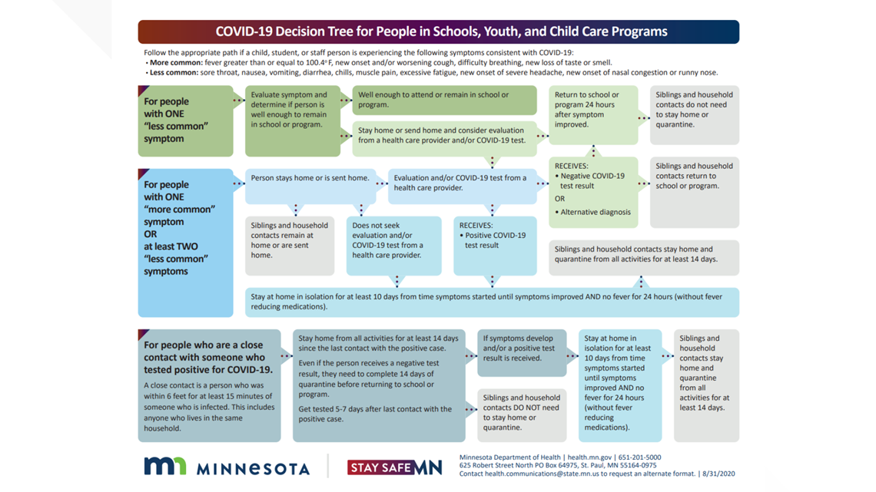

I will notify you as soon as possible if any of these symptoms occur at childcare, and you will need to make arrangements to have your child picked up with in an hour.

** Please notify me within 24 hours if your child is diagnosed with a serious contagious illness. By signing this contract you are allowing me to give medication to your child (fill out medication sheet). I will only give medication that is in the original container, with precise instructions and your child’s name on it.

**If my children or I become ill and I cannot provide care, I will notify you as soon as possible. If this occurs during childcare hours, you will be contacted and asked to make arrangements to have your child picked up within an hour. You are responsible. For having back up childcare available. Days that your child misses due to illnesses and other appointments are still paid.

** I’m allowed to use 5 paid sick days at my discretion in the event of myself or my children get sick. (paid 5 sick days) year runs Jan 1st –Dec 31st.
After 5 sick days in a year you will not be charged for sick days I close! Unless it’s a covid-19 closure.

All visitors and parents are recommended but not required to wear masks at drop off and pick up or to enter our home per governors mandate if you have any exclusions please text me to meet you at the door for meeting to drop off or pick up child. Children and I while in my care are not required to wear facemasks at this time.

If at any time I have to close due to covid exposure you still are required to pay weekly rate until fully back opened. This will help ensure the childcare spot be available after reopening. Ifs its covid-19 closure longer than 14 days you will not be charged for anything past the 14 days.

If your child is out due to positive covid test please provide dr note so I can document it and take necessary precautions. Days your child misses still requires full payment to ensure their spot is held. I follow the decision tree on these exposures recommendations.
I realized that this is such a hard time for all parents and businesses and I appreciate all of you !

Mandated Reporting: ​I am mandated to report any suspected child abuse or neglect to Otter Tail County Social Services and certain serious communicable diseases or parasitic infestations to the Minnesota Department of Public Health. Please sign the mandated reporter sheet acknowledging this info.

Complaint/Grievance Procedures: ​If at any time you are dissatisfied with the level of care or service I offer, please let me know immediately so I can address your concern. I welcome any suggestions that are reasonable and offer better care for children. If we have any issues we can’t work through or your concerned about feel free to reach out to my county worker her name and contact info is below. Lisa Spangler -218-998-8150.

Additional Comments or rules!!

I provide all diapers and wipes for those who need it! So no need to haul in diaper bags at this time.
All kiddos have a designated cubby where extra change of clothes is need to be kept. Please make sure to check to the cubby’s in case you need an extra outfit or weather appropriate clothing!

● No child should ever be left unattended in a vehicle at childcare-this includes non-childcare children.
Children in carseats need to be leaving in and placed in one when on my property for safety reasons. If you need help getting one feel free to ask me as I know of a few resources to help if needed!
● Potty training needs to be a cooperative effort between us. Parents need to initiate the training at home first before I can begin to help.

We have daily rest time from 1-230 please if you have to take your children to and from appointments to plan around this time as I won’t allow pick up and drops offs during this time as it disrupts those that need a nap during the day. Thank you!

● absolutely No toys or food or any other unnecessary items should be brought to childcare unless requested for special purposes. I am not responsible for items brought from home that break or get lost.

At pick up or drop off time please only have one family in the house at a time this will ensure privacy if I need to discuss your kiddos days or concerns and also help us maintain a good social distance procedure.

● All infants will be laid on their back in a pack and play to sleep.
● Infants will NOT be swaddled (prohibited for any infant who has begun to roll
Over independently).
● at rest time, infants will be laid to sleep in pack n plays, non-infants will have rest mats and pillows

**** ALL Infants must be able to nap in pack and plays AND TAKE A BOTTLE FROM ME to be enrolled in my care.

● I do not carry Family Childcare Liability Insurance.

***I may revise these policies at any time. You will be given a notice prior to any revisions going into effect.

You can expect me the provider to:
● Provide a loving and safe environment
● offer a variety of learning activities
● Have age appropriate toys, books, videos, music, etc.
● Maintain a safe, clean, smoke free environment
● Communicate with you about your child’s day and any questions or concerns that
I have
● Provide nutritious, well balanced meals and snacks
● Treat you and your family with respect.

I expect you the parents to:
● Read, fill out, sign and return required documents no later than the first day of care.
● Bring children clean and appropriately dressed for the weather and play.
● accompany your child to and from my house at drop off and pick up times.
● Notify me of any allergies, specific dietary requirements, or any other special
Needs your child may have.
● Provide necessary extras such as; extra clothing, pacifiers, any extras they may need to help accommodate them here at care.
● be prompt with arrival times and pick up times as well as payments
● Have an alternative contact person for me to call in the case of an emergency.
● Treat me, my family, my home, and the children in my care with respect.
● Inform me if you will not be at work or your usual destination during the day so
You can be reached in the case of emergency.
Keep open communication with me about any issues changes etc!

Advantages of my Childcare:
*Parent aware participant!
● Music education major
● Licensed childcare provider
● Participant CCNI Food Program
● SUIDS & AHT certified
● First Aid and CPR certified
*Car seat transport safety training
● Continuing Educational Classes throughout the year to further my ability to
Provide care.

